CrossWay Church – Macky Shedd – February 8th, 2026

There were others who were tortured, refusing to be released so that they might gain an even better resurrection. ³⁶ Some faced jeers and flogging, and even chains and imprisonment. ³⁷ They were put to death by stoning; they were sawed in two; they were killed by the sword. They went about in sheepskins and goatskins, destitute, persecuted and mistreated— ³⁸ the world was not worthy of them. They wandered in deserts and mountains, living in caves and in holes in the ground. ³⁹ These were all commended for their faith, yet none of them received what had been promised, ⁴⁰ since God had planned something better for us so that only together with us would they be made perfect. Hebrews 11:35b-40 (NIV)

Faith based on the lack of ___________ is on the brink of ___________.

Even though the fig trees have no blossoms, and there are no grapes on the vines; even though the olive crop fails, and the fields lie empty and barren; even though the flocks die in the fields, and the cattle barns are empty, ¹⁸ yet I will rejoice in the Lord! I will be joyful in the God of my salvation! ¹⁹ The Sovereign Lord is my strength! He makes me as surefooted as a deer, able to tread upon the heights. (For the choir director: This prayer is to be accompanied by stringed instruments.) Habakkuk 3:17-19 (NLT)

Even though I walk through the valley of the shadow of death, I will fear no evil, for you are with me; your rod and your staff, they comfort me. Psalm 23:4 (ESV)

If I can’t see God in the present, _________________________________.

This prayer was sung by the prophet Habakkuk: ² I have heard all about you, Lord. I am filled with awe by your amazing works. In this time of our deep need, help us again as you did in years gone by. And in your anger, remember your mercy. Habakkuk 3:1-2 (NLT)

“Since we are surrounded by such a huge crowd of witnesses to the life of faith, let us strip off every weight that slows us down, especially the sin that so easily hinders our progress. And let us run with endurance the race that God has set before us. We do this by keeping our eyes on Jesus, on whom our faith depends from start to finish. Jesus was willing to die a shameful death on the cross because of the joy he knew would be his afterward. Now he is seated in the place of highest honor beside God’s throne in heaven. Think about all he endured when sinful people did such terrible things to him, so that you don’t become weary and give up!” Hebrews 12:1-3 (NLT)

7 Keys To Handling Stress Faithfully When Life Gets Hard:

- REMEMBER HOW MUCH _________________________.

“The Father loves me…” John 10:17a (NLT)

“As the Father has loved me, so have I loved you. Now remain in my love. ¹⁰ If you keep my commands, you will remain in my love…” John 15:9-10a (NIV)

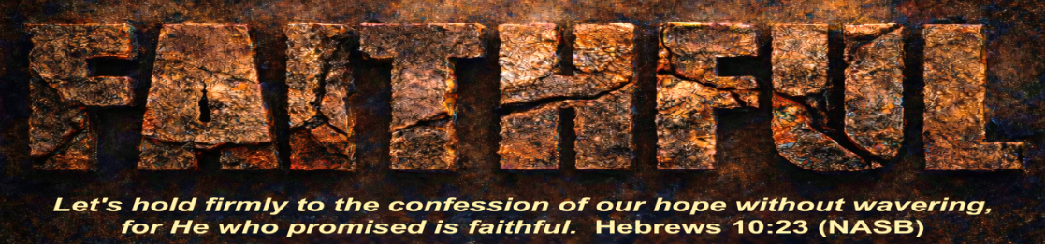
See what great love the Father has lavished on us, that we should be called children of God! And that is what we are! 1 John 3:1a (NIV)
- REMEMBER WHO GOD _________________.

“I am…the Light of the world…the Son of God…the Way, the Truth and the Life…the Bread of life…” Mark 14:62, John 6:35, 8:12, 14:6 (NIV)

I testify on my own behalf, and so does the Father who sent me.” John 8:18 (GW)

“You are the salt of the earth…¹⁴ “You are the light of the world. A town built on a hill cannot be hidden.” Matthew 5:13a, 14 (NIV)

- REMEMBER I LIVE TO ______________________________________.

“…I am not trying to do what I want, but only what he who sent me wants.” John 5:30b (GNT)

“I always do the things that are pleasing to Him.” John 8:29b (NASB)

“No one can serve two masters…” Luke 16:13a (NIV)

Obviously, I’m not trying to win the approval of people, but of God. If pleasing people were my goal, I would not be Christ’s servant. Galatians 1:10 (NLT)

- REMEMBER MY ________________________________________.

“…I know where I came from and where I am going...” John 8:14b (NIV)

A person who has doubts is thinking about two different things at the same time and can’t make up his mind about anything. James 1:8 (GW)

…I urge you to live a life worthy of the calling you have received. Ephesians 4:1b (NIV)

- REMEMBER WHAT ________________________________________.

As the time drew near for his return to heaven, he moved steadily onward toward Jerusalem with an iron will. Luke 9:51 (TLB)

“Anyone who lets himself be distracted from the work I plan for him is not fit for the Kingdom of God.” Luke 9:62 (TLB)

“I have the right to do anything,” you say—but not everything is beneficial. “I have the right to do anything”—but not everything is constructive.1 Corinthians 10:23 (NIV)

- REMEMBER TO ___________________________________________.

Jesus often went away to other places to be alone so that he could pray. Luke 22:39 (ERV)

Very early in the morning, while it was still dark, Jesus got up, left the house and went off to a solitary place, where he prayed. Mark 1:35 (NIV)

But the news about Jesus spread even more. Many people came to hear Jesus and to be healed of their sicknesses, ¹⁶ but Jesus often slipped away to be alone so he could pray. Luke 5:15-16 (NCV)

Plant your roots in Christ and let him be the foundation for your life… Colossians 2:7a (CEV)

- REMEMBER I DON’T _________________________________.

He appointed twelve[a] that they might be with him… Mark 3:14a (NIV)

Then he said to them, “My soul is overwhelmed with sorrow to the point of death. Stay here and keep watch with me.” Matthew 26:38 (NIV)

Therefore, since we are surrounded by such a great cloud of witnesses, let us throw off everything that hinders and the sin that so easily entangles. And let us run with perseverance the race marked out for us… Hebrews 12:1 (NIV)

