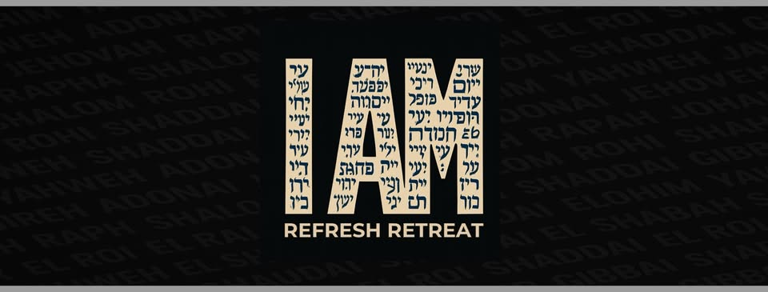
The Crossings Church – Ben Hupert & Fernando Sucre – January18th, 2026

Jesus said, “Don’t let your hearts be troubled. Trust in God, and trust in me. ² There are many rooms in my Father’s house; I would not tell you this if it were not true. I am going there to prepare a place for you. ³ After I go and prepare a place for you, I will come back and take you to be with me so that you may be where I am. ⁴ You know the way to the place where I am going.” ⁵ Thomas said to Jesus, “Lord, we don’t know where you are going. So how can we know the way?” ⁶ Jesus answered, “I am the way, and the truth, and the life. The only way to the Father is through me. John 14:1-6 (NCV)

Jesus said “I Am”… (Greek: __________________ )

The Resurrection & The Life The Gate The Light Of The World The Bread Of Life The True Vine The Good Shepherd The Way, The Truth, & The Life

“Very truly I tell you,” Jesus answered, “before Abraham was born, I AM!” John 8:58 (NIV)

- Jesus Doesn’t Say “I’m Him” To ________, But “I Am” To ____________.

Moses said to God, “Suppose I go to the Israelites and say to them, ‘The God of your fathers has sent me to you,’ and they ask me, ‘What is his name?’ Then what shall I tell them?” ¹⁴ God said to Moses, “I am who I am. This is what you are to say to the Israelites: ‘I am has sent me to you.’” Exodus 3:13-14 (NIV)

- The Voice From The ________ Is Now Speaking In The __________.

Then Jesus, knowing everything that was going to happen, went forward and asked them, “Who are you looking for?” ⁵ They answered him, “Jesus from Nazareth.” Jesus told them, “I AM.” Judas, the man who betrayed him, was standing with them. ⁶ When Jesus told them, “I AM,” they backed away and fell to the ground. John 18:4-6 (ISV)

- Our Best Starting ______________ Is On The ____________.

THINGS ABOUT THE I AM THAT CAN CHANGE WHO I AM:

JESUS IS THE WAY, SO AS A DISCIPLE I SHOULD…

- _________________________________________________________.

He appointed twelve that they might be with him… Mark 3:14a (NIV)

Jesus said to them, “Come, follow Me, and I will make you fishers of men.” Mark 1:17 (MEV)

- ______________________ Is The ______________________.

- _________________________________________________________.

“Enter through the narrow gate. For wide is the gate and broad is the road that leads to destruction, and many enter through it. ¹⁴ But small is the gate and narrow the road that leads to life, and only a few find it. Matthew 7:13-14 (NIV)

- You can’t _________________ & expect to get _________________.

JESUS IS THE TRUTH, SO AS A DISCIPLE I SHOULD…

- _________________________________________________________.

Whoever is blessed in the land will be blessed by the God of truth… Isaiah 65:16a (HCSB)

By all means, do not believe in Me, if I am not doing the things of the Father. ³⁸ But examine My actions, and you will see that My work is the work of the Father. Regardless of whether you believe in Me—believe the miracles. Then you will know that the Father is in Me, and I am in the Father. John 10:37-38 (VOICE)

- ____________________________________________________________.

The heart is deceitful above all things, and desperately sick; who can understand it? Jeremiah 17:9 (ESV)

…sing and make music with your hearts attuned to God… Ephesians 5:19b (VOICE)

Now set your mind and heart to seek the Lord your God. 1 Chronicles 22:19 (ESV)

- _________________________________________________________.

You will never succeed in life if you try to hide your sins. Confess them and give them up; then God will show mercy to you. Proverbs 28:13 (GNT)

- The Greatest _______________ To ______________ Is __________.

Instead, we will speak the truth in love, growing in every way more and more like Christ, who is the head of his body, the church. Ephesians 4:15 (NLT)

JESUS IS THE LIFE, SO AS A DISCIPLE I SHOULD…

- _________________________________________________________.

The thief comes only to steal and kill and destroy. I came that they may have life and have it abundantly. John 10:10 (ESV)

- _________________________________________________________.

If the Spirit of the One who resurrected Jesus from the dead lives inside of you, then you can be sure that He who raised Him will cast the light of life into your mortal bodies through the life-giving power of the Spirit residing in you. Romans 8:11 (VOICE)

- Be ______________________, Not Just ________________.

My little children, again I feel the pain of childbirth for you until you truly become like Christ. Galatians 4:19 (NCV)

So I say, let the Holy Spirit guide your lives. Then you won’t be doing what your sinful nature craves. Galatians 5:16 (NLT)

Since we are living by the Spirit, let us follow the Spirit’s leading in every part of our lives. Galatians 5:25 (NLT)

And the Lord—who is the Spirit—makes us more and more like him as we are changed into his glorious image. 2 Corinthians 3:18b (NLT)

- _________________________________________________________.

In him was life, and that life was the light of all mankind. ⁵ The light shines in the darkness, and the darkness has not overcome it. John 1:4-5 (NIV)

- It's Scarier ___________________ Jesus Than ________________.

Since, then, we know what it is to fear the Lord, we try to persuade others. 2 Corinthians 5:11 (NIV)

