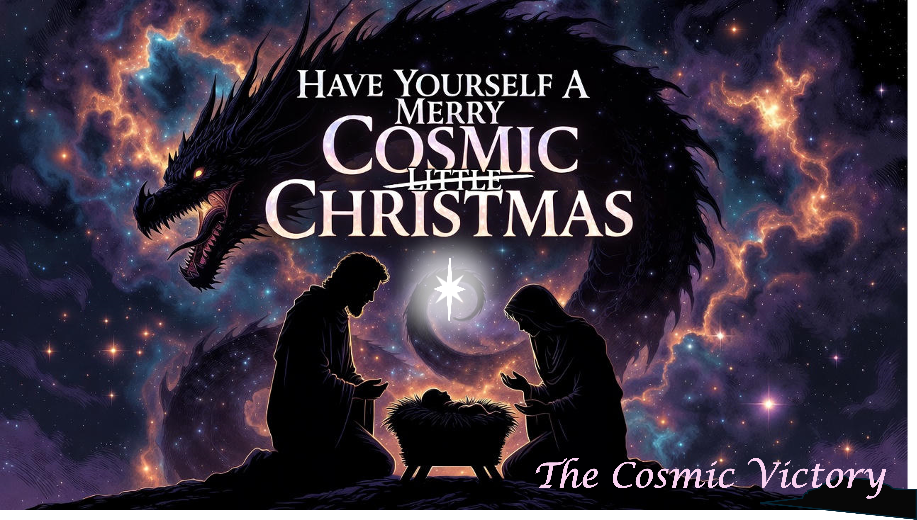
CrossWay Church – Macky Shedd – December 21st, 2025

Then war broke out in heaven. Michael and his angels fought against the dragon, and the dragon and his angels fought back. ⁸ But he was not strong enough, and they lost their place in heaven. ⁹ The great dragon was hurled down—that ancient serpent called the devil, or Satan, who leads the whole world astray. He was hurled to the earth, and his angels with him. ¹⁰ Then I heard a loud voice in heaven say: “Now have come the salvation and the power and the kingdom of our God, and the authority of his Messiah. For the accuser of our brothers and sisters, who accuses them before our God day and night, has been hurled down. ¹¹ They triumphed over him by the blood of the Lamb and by the word of their testimony; they did not love their lives so much as to shrink from death. Revelation 12:7-11 (NIV)

Christmas Didn’t Just Start A __________. It Sealed The ____________!

I Can Find Cosmic Victory Over The Darkness When I…

L ____ My Mind Be Ruled By ______ & Not ________.

That night there were shepherds staying in the fields nearby, guarding their flocks of sheep. ⁹ Suddenly, an angel of the Lord appeared among them, and the radiance of the Lord’s glory surrounded them. They were terrified, ¹⁰ but the angel reassured them. “Don’t be afraid!” he said. “I bring you good news that will bring great joy to all people. ¹¹ The Savior—yes, the Messiah, the Lord—has been born today in Bethlehem, the city of David! ¹² And you will recognize him by this sign: You will find a baby wrapped snugly in strips of cloth, lying in a manger.” Luke 2:8-12 (NLT)

My ________ Is Not My ____________.

I cannot find peace or remember happiness. ¹⁸ I tell myself, “I am finished! I can't count on the Lord to do anything for me.” ¹⁹ Just thinking of my troubles and my lonely wandering makes me miserable. ²⁰ That's all I ever think about, and I am depressed. Lamentations 3:17-20 (CEV)

Joy Is A __________ Before It’s A ______________.

But then I choose to remember God, and this is my hope: ²² The Lord’s faithful love never comes to an end. He never stops being kind to us. ²³ Every day, we can trust him to be kind again. We know that he will do what he has promised to do. Lamentations 3:21-23 (EEB)

I _____________________ God’s ________ & __________.

¹³ He is dressed in a robe dipped in blood, and his name is the Word of God. ¹⁴ The armies of heaven were following him, riding on white horses and dressed in fine linen, white and clean. Revelation 19:13-14 (NIV)

God Is Not ________________________ & ________________________.

Because we broke God’s laws, we owed a debt—a debt that listed all the rules we failed to follow. But God forgave us of that debt. He took it away and nailed it to the cross. ¹⁵ He defeated the rulers and powers of the spiritual world. With the cross he won the victory over them and led them away, as defeated and powerless prisoners for the whole world to see. Colossians 2:14-15 (ERV)
G _________ That __________ & ______ Don’t Win.

The reason the Son of God appeared was to destroy the devil’s work. 1 John 3:8b (NIV)

I am the Living One; I was dead, and now look, I am alive for ever and ever! And I hold the keys of death and Hades. Revelation 1:18 (NIV)

And they have defeated him by the blood of the Lamb and by their testimony. And they did not love their lives so much that they were afraid to die. Revelation 12:11 (NLT)

Because God’s children are human beings—made of flesh and blood—the Son also became flesh and blood. For only as a human being could he die, and only by dying could he break the power of the devil, who had the power of death. ¹⁵ Only in this way could he set free all who have lived their lives as slaves to the fear of dying. Hebrews 2:14-15 (NLT)

Jesus Entered A ________________, So He Could _________________!

I declare to you, brothers and sisters, that flesh and blood cannot inherit the kingdom of God, nor does the perishable inherit the imperishable. ⁵¹ Listen, I tell you a mystery: We will not all sleep, but we will all be changed— ⁵² in a flash, in the twinkling of an eye, at the last trumpet. For the trumpet will sound, the dead will be raised imperishable, and we will be changed…then the saying that is written will come true: “Death has been swallowed up in victory.” ⁵⁵ “Where, O death, is your victory? Where, O death, is your sting?” ⁵⁶ The sting of death is sin, and the power of sin is the law. ⁵⁷ But thanks be to God! He gives us the victory through our Lord Jesus Christ. 1 Corinthians 15:50-52, 54b-57 (NIV)

H _______ In God’s ________________.

Then I saw “a new heaven and a new earth,” for the first heaven and the first earth had passed away, and there was no longer any sea. ² I saw the Holy City, the new Jerusalem, coming down out of heaven from God, prepared as a bride beautifully dressed for her husband. ³ And I heard a loud voice from the throne saying, “Look! God’s dwelling place is now among the people, and he will dwell with them. They will be his people, and God himself will be with them and be their God. ⁴ ‘He will wipe every tear from their eyes. There will be no more death or mourning or crying or pain, for the old order of things has passed away.” ⁵ He who was seated on the throne said, “I am making everything new!” Then he said, “Write this down, for these words are trustworthy and true.” Revelation 21:1-5 (NIV)

We Live In A ________, But We Have A ________________!

Jesus said to her, “I am the resurrection and the life. The one who believes in me will live, even though they die; ²⁶ and whoever lives by believing in me will never die. Do you believe this?” John 11:25-26 (NIV)

T _______ Time To ________ Up.

Lord, how many are my foes! How many rise up against me! ² Many are saying of me,“God will not deliver him.” ³ But you, Lord, are a shield around me, my glory, the One who lifts my head high. Psalm 3:1-3 (NIV)

We Are In Dragon Territory Not As ____________ But As ____________.

The people walking in darkness have seen a great light; on those living in the land of deep darkness a light has dawned. ⁶ For to us a child is born, to us a son is given, and the government will be on his shoulders. And he will be called Wonderful Counselor, Mighty God, Everlasting Father, Prince of Peace. Isaiah 9:2, 6 (NIV)

