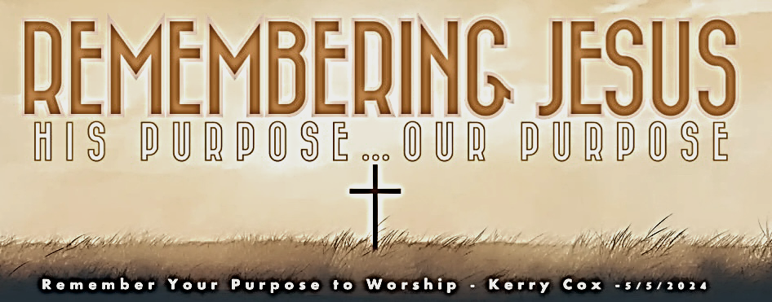

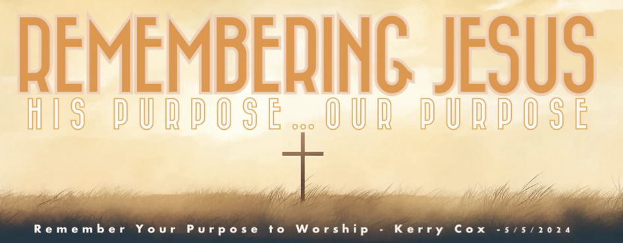
Purpose #3 – I Am Molded To Be Like My Maker & Master

CrossWay Church – Macky Shedd – May 26th, 2024

He gave His body for our sakes and will not only break us free from the chains of wickedness, but He will also prepare a community uncorrupted by the world that He would call His own—people who are passionate about doing the right thing. Titus 2:14 (VOICE)

Whoever claims to live in him must live as Jesus did. 1 John 2:6 (NIV)

A talmid is not above his rabbi; but each one, when he is fully trained, will be like his rabbi. Luke 6:40 (CJB)

God’s purpose for me is not just being ________ but being ___________________.

…He also destined from the beginning [foreordaining them] to be molded into the image of His Son [and share inwardly His likeness], that He might become the firstborn among many brethren. Romans 8:29 (AMPC)

The word of the Eternal came to Jeremiah.² Go down to the potter’s shop … ³ So I went …and found him making something on his wheel. ⁴ And as I watched, the clay vessel in his hands became flawed and unusable. So the potter started again with the same clay. He crushed and squeezed and shaped it into another vessel that was to his liking. ⁵ In that moment, I heard again God’s word for His rebellious people. ⁶ O people of Israel, can I not do the same to you as this potter has done? You are like clay in My hands—I will mold you as I see fit. Jeremiah 18:1-6 (VOICE)

For we are His workmanship [His own master work, a work of art] Ephesians 2:10a (AMP)

“You stubborn people! You are heathen at heart and deaf to the truth. Must you forever resist the Holy Spirit? That’s what your ancestors did, and so do you! Acts 7:51 (NLT)

_____________________ = decision & process of becoming like Jesus.

To the Jews who had believed him, Jesus said, “If you hold to my teaching, you are really my disciples. ³² Then you will know the truth, and the truth will set you free.” ³³ They answered him, “We are Abraham’s descendants and have never been slaves of anyone. How can you say that we shall be set free?” ³⁴ Jesus replied, “Very truly I tell you, everyone who sins is a slave to sin. ³⁵ Now a slave has no permanent place in the family, but a son belongs to it forever. ³⁶ So if the Son sets you free, you will be free indeed. John 8:31-36 (NIV) (37-44 on screen)

Normally it takes only eleven days to travel from Mount Sinai^{[b]} to Kadesh-barnea, going by way of Mount Seir. ³ But forty years after the Israelites left Egypt, on the first day of the eleventh month, Moses addressed the people of Israel, telling them everything the Lord had commanded him to say. Deuteronomy 1:2-3 (NLT)

3 tools that god uses to MOLD ME LIKE MY MASTER:

- GOD uses ______________________ ________ to mold me.

- TRASH = ____________ ________

Act like people with good sense and not like fools. ¹⁶ These are evil times, so make every minute count. ¹⁷ Don't be stupid. Instead, find out what the Lord wants you to do. Ephesians 5:15-17 (CEV)
  - My Time Spent __________________________________________.
Long ago I promised the ancestors of Israel that I would give this land to their descendants. So be strong and brave! Be careful to do everything my servant Moses taught you. Never stop reading The Book of the Law[a] he gave you. Day and night you must think about what it says. If you obey it completely, you and Israel will be able to take this land. Joshua 1:6-8 (CEV)

- My Time Spent __________________________________________.
“Abba, Father,” he cried out, “everything is possible for you. Please take this cup of suffering away from me. Yet I want your will to be done, not mine.” Mark 14:36 (NLT)

- God uses ____________ to Mold Me.

- Trash = ______ ____________________
Do not be misled: “Bad company corrupts good character.” 1 Corinthians 15:33 (NIV)

If you have wise people as your friends, you will become wise yourself. But if you have foolish friends, you will hurt yourself. Proverbs 13:20 (EASY)

Now these are the gifts Christ gave to the church: the apostles, the prophets, the evangelists, and the pastors and teachers. ¹² Their responsibility is to equip God’s people to do his work and build up the church…¹⁴ Then we will no longer be immature like children…¹⁵ Instead, we will speak the truth in love, growing in every way more and more like Christ… Ephesians 4:11-15 (NLT)

As iron sharpens iron, so a friend sharpens a friend. Proverbs 27:17 (NLT)

  - “Iron sharpening” & my sharpening requires…

____________________ – One who knows how to sharpen me.
They want to be teachers of the Law of Moses. But they don't know what they are talking about, even though they think they do. 1 Timothy 1:7 (CEV)

______________ – One who will take the time to sharpen me.

________________ – One who is willing to battle me to better me.

________ – One who hurts me from a desire to help me.
Faithful are the wounds of a friend [who corrects out of love and concern], But the kisses of an enemy are deceitful [because they serve his hidden agenda]. Proverbs 27:6 (AMP)

- God uses ________________ to mold me.

- TRASH = ____________________________ ________________
Of course, you get no credit for being patient if you are beaten for doing wrong. But if you suffer for doing good and endure it patiently, God is pleased with you. 1 Peter 2:20 (NLT)

Dear brothers, is your life full of difficulties and temptations? Then be happy, ³for when the way is rough, your patience has a chance to grow. ⁴So let it grow, and don’t try to squirm out of your problems. For when your patience is finally in full bloom, then you will be ready for anything, strong in character, full and complete.” James 1:2-4 (TLB)

  - my part in the molding process? __________________
Large crowds were traveling with Jesus, and turning to them he said: ²⁶ “If anyone comes to me and does not hate father and mother, wife and children, brothers and sisters—yes, even their own life—such a person cannot be my disciple. ²⁷ And whoever does not carry their cross and follow me cannot be my disciple. Luke 14:25-27 (NIV)

Purpose #3 – I Am Molded To Be Like My Maker & Master

CrossWay Church – Macky Shedd – May 26th, 2024

He gave His body for our sakes and will not only break us free from the chains of wickedness, but He will also prepare a community uncorrupted by the world that He would call His own—people who are passionate about doing the right thing. Titus 2:14 (VOICE)

Whoever claims to live in him must live as Jesus did. 1 John 2:6 (NIV)

A talmid is not above his rabbi; but each one, when he is fully trained, will be like his rabbi. Luke 6:40 (CJB)

God’s purpose for me is not just being ________ but being ___________________.

…He also destined from the beginning [foreordaining them] to be molded into the image of His Son [and share inwardly His likeness], that He might become the firstborn among many brethren. Romans 8:29 (AMPC)

The word of the Eternal came to Jeremiah.² Go down to the potter’s shop … ³ So I went …and found him making something on his wheel. ⁴ And as I watched, the clay vessel in his hands became flawed and unusable. So the potter started again with the same clay. He crushed and squeezed and shaped it into another vessel that was to his liking. ⁵ In that moment, I heard again God’s word for His rebellious people. ⁶ O people of Israel, can I not do the same to you as this potter has done? You are like clay in My hands—I will mold you as I see fit. Jeremiah 18:1-6 (VOICE)

For we are His workmanship [His own master work, a work of art] Ephesians 2:10a (AMP)

“You stubborn people! You are heathen at heart and deaf to the truth. Must you forever resist the Holy Spirit? That’s what your ancestors did, and so do you! Acts 7:51 (NLT)

_____________________ = decision & process of becoming like Jesus.

To the Jews who had believed him, Jesus said, “If you hold to my teaching, you are really my disciples. ³² Then you will know the truth, and the truth will set you free.” ³³ They answered him, “We are Abraham’s descendants and have never been slaves of anyone. How can you say that we shall be set free?” ³⁴ Jesus replied, “Very truly I tell you, everyone who sins is a slave to sin. ³⁵ Now a slave has no permanent place in the family, but a son belongs to it forever. ³⁶ So if the Son sets you free, you will be free indeed. John 8:31-36 (NIV) (37-44 on screen)

Normally it takes only eleven days to travel from Mount Sinai^{[b]} to Kadesh-barnea, going by way of Mount Seir. ³ But forty years after the Israelites left Egypt, on the first day of the eleventh month, Moses addressed the people of Israel, telling them everything the Lord had commanded him to say. Deuteronomy 1:2-3 (NLT)

3 tools that god uses to MOLD ME LIKE MY MASTER:

- GOD uses ______________________ ________ to mold me.

- TRASH = ____________ ________

Act like people with good sense and not like fools. ¹⁶ These are evil times, so make every minute count. ¹⁷ Don't be stupid. Instead, find out what the Lord wants you to do. Ephesians 5:15-17 (CEV)
  - My Time Spent __________________________________________.
Long ago I promised the ancestors of Israel that I would give this land to their descendants. So be strong and brave! Be careful to do everything my servant Moses taught you. Never stop reading The Book of the Law[a] he gave you. Day and night you must think about what it says. If you obey it completely, you and Israel will be able to take this land. Joshua 1:6-8 (CEV)

- My Time Spent __________________________________________.
“Abba, Father,” he cried out, “everything is possible for you. Please take this cup of suffering away from me. Yet I want your will to be done, not mine.” Mark 14:36 (NLT)

- God uses ____________ to Mold Me.

- Trash = ______ ____________________
Do not be misled: “Bad company corrupts good character.” 1 Corinthians 15:33 (NIV)

If you have wise people as your friends, you will become wise yourself. But if you have foolish friends, you will hurt yourself. Proverbs 13:20 (EASY)

Now these are the gifts Christ gave to the church: the apostles, the prophets, the evangelists, and the pastors and teachers. ¹² Their responsibility is to equip God’s people to do his work and build up the church…¹⁴ Then we will no longer be immature like children…¹⁵ Instead, we will speak the truth in love, growing in every way more and more like Christ… Ephesians 4:11-15 (NLT)

As iron sharpens iron, so a friend sharpens a friend. Proverbs 27:17 (NLT)

  - “Iron sharpening” & my sharpening requires…

____________________ – One who knows how to sharpen me.
They want to be teachers of the Law of Moses. But they don't know what they are talking about, even though they think they do. 1 Timothy 1:7 (CEV)

______________ – One who will take the time to sharpen me.

________________ – One who is willing to battle me to better me.

________ – One who hurts me from a desire to help me.
Faithful are the wounds of a friend [who corrects out of love and concern], But the kisses of an enemy are deceitful [because they serve his hidden agenda]. Proverbs 27:6 (AMP)

- God uses ________________ to mold me.

- TRASH = ____________________________ ________________
Of course, you get no credit for being patient if you are beaten for doing wrong. But if you suffer for doing good and endure it patiently, God is pleased with you. 1 Peter 2:20 (NLT)

Dear brothers, is your life full of difficulties and temptations? Then be happy, ³for when the way is rough, your patience has a chance to grow. ⁴So let it grow, and don’t try to squirm out of your problems. For when your patience is finally in full bloom, then you will be ready for anything, strong in character, full and complete.” James 1:2-4 (TLB)

  - my part in the molding process? __________________
Large crowds were traveling with Jesus, and turning to them he said: ²⁶ “If anyone comes to me and does not hate father and mother, wife and children, brothers and sisters—yes, even their own life—such a person cannot be my disciple. ²⁷ And whoever does not carry their cross and follow me cannot be my disciple. Luke 14:25-27 (NIV)

