CrossWay Church – Macky Shedd – April 14th, 2024

- what CAN cause you & I to feel hopeless?

When I experience “UNBEARABLE” EVENTS.

No trial has overtaken you that is not faced by others. And God is faithful: He will not let you be tried beyond what you are able to bear, but with the trial will also provide a way out so that you may be able to endure it. 1 Corinthians 10:13 (NET)

When I have UNANSWERED QUESTIONS.

A song for pilgrims ascending to Jerusalem. A psalm of David. Lord, my heart is not proud; my eyes are not haughty. I don’t concern myself with matters too great or too awesome for me to grasp. Psalm 131:1 (NLT)

When I am ISOLATED and/or ALONE.

The Lord God said, “It is not good for the man to be alone. I will make a helper suitable for him.” Genesis 2:18 (NIV)

Two are better than one, because they have a good return for their labor:
¹⁰ If either of them falls down, one can help the other up. But pity anyone who falls and has no one to help them up. Ecclesiastes 4:9-10 (NIV)

When I feel WEAK and/or INADEQUATE.

When the angel of the Lord appeared to Gideon, he said, “The Lord is with you, mighty warrior.” Judges 6:12 (NIV)

When I get TIRE and/or OVERWHELMED.

We were under great pressure, far beyond our ability to endure, so that we despaired of life itself. ⁹ Indeed, we felt we had received the sentence of death. But this happened that we might not rely on ourselves but on God, who raises the dead. ¹⁰ He has delivered us from such a deadly peril, and he will deliver us again. On him we have set our hope that he will continue to deliver us, ¹¹ as you help us by your prayers. 2 Corinthians 1:8b-11a (NIV)

- FOUR hope giving PRACTICES that Mary PROVIDES:

- LISTEN TO WHAT GOD HAS ALREADY REVEALED.

You are my refuge and my shield; Your word is my source of hope. Psalms 119:114 (NLT)

We must pay the most careful attention, therefore, to what we have heard, so that we do not drift away. Hebrews 2:1 (NIV)

- Hope is found as I listen to the POSITIVE parts of scripture.

In the sixth month of Elizabeth's pregnancy, God sent the angel Gabriel to Nazareth, a town in Galilee, ²⁷ to a virgin pledged to be married to a man named Joseph, a descendant of David. The virgin's name was Mary. ²⁸ The angel went to her and said, "Greetings, you who are highly favored! The Lord is with you." Luke 1:26-28 (NIV)
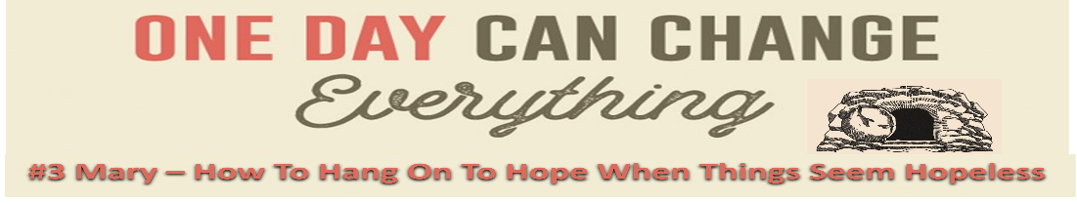
- Hope is found as I listen to the PROBLEMATIC parts of scripture.

For my eyes have seen your salvation, ³¹ which you have prepared in the sight of all nations: ³² a light for revelation to the Gentiles, and the glory of your people Israel." ³³ The child's father and mother marveled at what was said about him. ³⁴ Then Simeon blessed them and said to Mary, his mother: “This child is destined to cause the falling and rising of many in Israel, and to be a sign that will be spoken against, ³⁵ so that the thoughts of many hearts will be revealed. And a sword will pierce your own soul too.” Luke 2:30-35 (NIV)

But Mary treasured up all these words, pondering in her heart what they might mean. Luke 2:19 (NET)

I've told you all this so that trusting me, you will be unshakable and assured, deeply at peace. In this godless world you will continue to experience difficulties. But take heart! I've conquered the world. John 16:33 (MSG)

Then the disciple who had reached the tomb first also went in, and he saw and believed— ⁹ for until then they still hadn’t understood the Scriptures that said Jesus must rise from the dead. John 20:8-9 (NLT)

- I ACKNOWLEDGE how I am FEELING.

Mary was deeply troubled by the angel's message, and she wondered what his words meant. ³⁰ The angel said to her, "Don't be afraid, Mary; God has been gracious to you. ³¹ You will become pregnant and give birth to a son, and you will name him Jesus. ³² He will be great and will be called the Son of the Most High God. The Lord God will make him a king, as his ancestor David was, ³³ and he will be the king of the descendants of Jacob forever; his kingdom will never end!" ³⁴ Mary said to the angel, "I am a virgin. How, then, will this be?"… ³⁸ "I am the Lord's servant," said Mary; "may it happen to me as you have said." And the angel left her. Luke 1:29-34, 38 (GNT)

Give all your worries and cares to God, for He cares about you. 1 Peter 5:7 (NLT)

- I HANG OUT with THE people who can HELP me.
He comforts us in all our troubles so that we can comfort others. When they are troubled, we will be able to give them the same comfort God has given us. 2 Corinthians 1:4 (NLT)

But standing by the cross of Jesus were his mother and his mother's sister, Mary the wife of Clopas, and Mary Magdalene. John 19:25 (ESV)

Jesus saw his mother and the disciple he loved standing there; so he said to his mother, "He is your son." ²⁷ Then he said to the disciple, "She is your mother." From that time the disciple took her to live in his home. John 19:26-27 (GNT)

The apostles often met together and prayed with a single purpose in mind. The women and Mary the mother of Jesus would meet with them, and so would his brothers. Acts 1:14 (CEV)

I don’t spend time with people who tell lies. I don’t keep company with pretenders.
Psalm 26:4 (NIRV)

- I TRUST & OBEY God.

The angel replied, “The Holy Spirit shall come upon you, and the power of God shall overshadow you; so the baby born to you will be utterly holy—the Son of God… ³⁷ For every promise from God shall surely come true.” ³⁸ Mary said, “I am the Lord’s servant, and I am willing to do whatever he wants… Luke 1:35, 37-38a (TLB)

Lead me by your truth and teach me, for you are the God who saves me. All day long I put my hope in you. Psalm 25:5 (NLT)

